Modification of Plasma Membrane
Each cell has an apical domain (Free surface) and basolateral domain (lateral surfaces and a basal surface attached to the basal lamina).
1-Apical domain (Surface or luminal) modifications: It is specialized to carry out functions that occur at these interfaces, including secretion, absorption, and movement of luminal contents. For this purpose, the membrane of some cells is folded out into small projections
There are many types of these projections
Cilia and flagella
Are membrane-covered extensions of the entire apical surface. They beat in waves, often moving a surface coat of mucus and trapped materials. The cilia are about (5-10µm) long and (0.2 µm) in diameter. They are surrounded by cell membrane and contain central pair of microtubules and around it arranged nine sets (pairs) of microtubules, this arrangement called axoneme originating from basal bodies (protein cylinder structure found beneath the plasma membrane associated with the formation of cilia and flagella).
The basal body orients and positions the cilium or flagellum and regulates the entry of proteins into the axoneme.

Cilia can be grouped into two categories.
First, there are motile cilia; found together on cells, always moving in a single direction and coordinate their movements to be most effective making up for their small size.
An epithelial cell in the trachea may have 250 cilia
The second type of cilia is non-motile cilia (primary cilia), which do not have central microtubules, they have a 9+0 structure and responsible for sensing the surrounding environment.
Cilia and flagella but the major difference is in their length.
Flagella have the same structure to cilia concerned with movement, but are much longer here is usually only one flagellum per cell, e.g. Sperm.

(1)
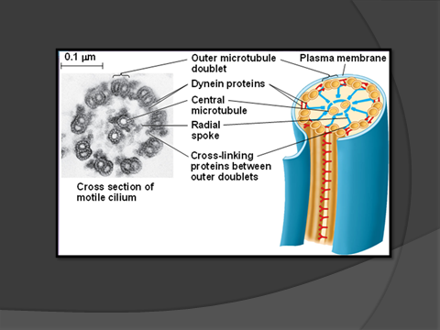

Microvilli
Are plasma membrane-covered extensions of the cell surface, Non-motile projections
coated with glycocalyx (glycolipids and glycoproteins surround the plasma membrane) that may contain enzymes disaccharides and peptidases.
The microvilli greatly increase the absorptive surface at the apex of the cell.
Example: apical surfaces of absorptive cells in the intestine and the apical surfaces of renal tubules.

Stereocilia ---Are not true cilia but long and branching finger-like projections from the apical surface (very long microvilli).
They are found in the male reproductive tract where they have an absorptive function, and in the internal ear, where they have a sensory function.
Stereocilia also increase the surface area of the cell and facilitate the movements of molecules into and out of the cell
Even though this structure has “cilia” in its name, the microtubular axoneme is absent and thus is non motile.

(2)
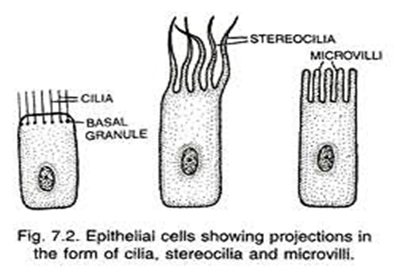

Caveolae: are small invaginations of plasma membrane in many cell types such as embryonic cells, endothelial cells and adipocytes cells.
Caveolae have flask shape, small in size about 50-100 nm, rich in proteins and lipids like cholesterol and sphingolipids. These structures play an important role in signal transduction by associate with some signaling molecules.
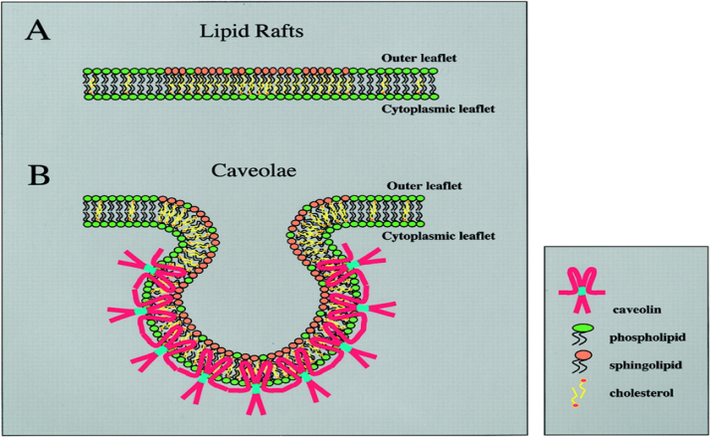

2- The basolateral domain modifications (proved by cell junctions):
In basolateral domain, between adjacent cells there are structures called cell junctions connect and help to communicate the cells with each other.
There are three major types of junctions
1-Occluding junctions (tight junctions)
Occluding junctions are symmetrical structures on opposite sides of two adjacent cells separating the apical domain from the basolateral domain, made up of transmembrane protein called claudin which forms linear fibrils. Its form a belt-like seal around the apical surfaces of two adjacent cells, so the junctions are very tight and prevent movement of lipids and proteins between adjacent cells.
(3)

2-Anchoring junctions:
Composed of three types of junctions belt- desmosome, spot- desmosome and hemi desmosome.
Anchoring junctions connect the cytoskeleton of a cell to the cytoskeleton of its neighbors or to the extracellular matrix and found bellow the tight junctions.
Belt desmosome and spot desmosome are symmetrical structures that anchor adjacent cells at the apical domains which provide strength and rigidity to the cell layer.
Hemidesmosomes are not symmetrical structures that anchor the basal domain of the cell to the basal lamina.
Anchoring junctions are widely distributed in animal tissues and most abundant tissues are subjected to several mechanical stresses, such as heart, muscle and epidermis.
3-Gap (communicating) junctions
There is a communication between cells in these junctions and that happened because this type of junctions forms channels between adjacent cells.
Gap or communicating junctions made up of integral membrane protein called connexins, have a little strength but serve as intercellular channels for flow materials (with small diameter 1.5 nm) and allow the passage of small signaling molecules between adjacent cells.
Most cells in animal tissues are in communication with their neighbors via gap junctions which present in most mammalian tissues, for example cardiac muscles and smooth muscles of the uterus.

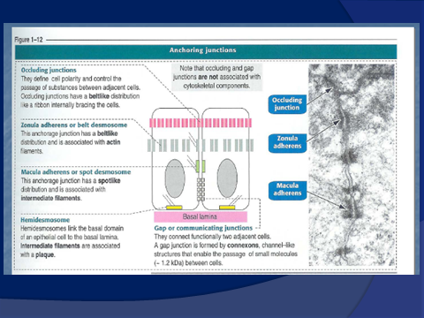

Generally, epithelial tissues have abundant cell junctions because the tissue composed of cells physically close together that are connected by one or all three types of junctions with very little intervening intercellular sub stances.

(5)

